**Week 2- Mandatory Hands-on**

**PLSQL Exercises**

**Exercise 1: Control Structures**

**Scenario 1:** The bank wants to apply a discount to loan interest rates for customers above 60 years old.

* + **Question:** Write a PL/SQL block that loops through all customers, checks their age, and if they are above 60, apply a 1% discount to their current loan interest rates.

**Customers Table:**

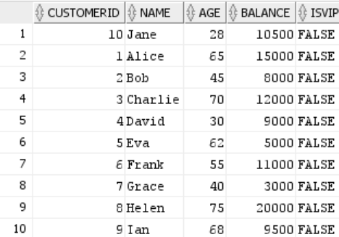

**Loans Table:**

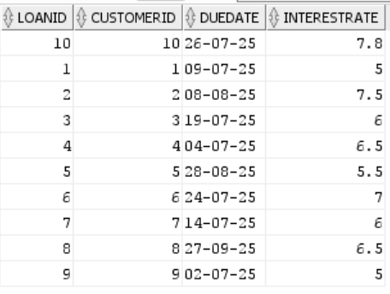

**Code:**

DECLARE

CURSOR c_loans IS

SELECT l.LoanID, l.InterestRate

FROM LOANS l

JOIN CUSTOMERS c ON l.CustomerID = c.CustomerID

WHERE c.Age > 60;

BEGIN

FOR rec IN c_loans LOOP

UPDATE LOANS

SET InterestRate = InterestRate - 1

WHERE LoanID = rec.LoanID;

END LOOP;

COMMIT;

DBMS_OUTPUT.PUT_LINE('Interest rate discounts applied to loans for customers over 60.');

END;

/

**Output:**

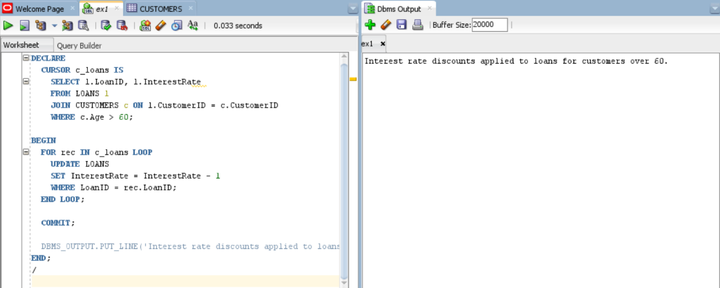

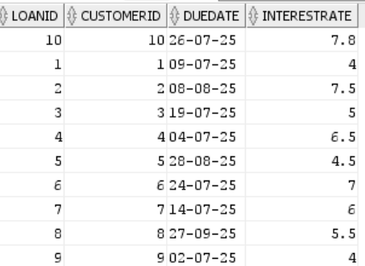

**Scenario 2:** A customer can be promoted to VIP status based on their balance.

* + **Question:** Write a PL/SQL block that iterates through all customers and sets a flag IsVIP to TRUE for those with a balance over $10,000.

**Code:**

DECLARE

CURSOR c_customers IS

SELECT CustomerID

FROM CUSTOMERS

WHERE Balance > 10000;

BEGIN

FOR rec IN c_customers LOOP

UPDATE CUSTOMERS

SET IsVIP = 'Y'

WHERE CustomerID = rec.CustomerID;

END LOOP;

COMMIT;

DBMS_OUTPUT.PUT_LINE('VIP status updated for eligible customers.');

END;

/

**Output:**

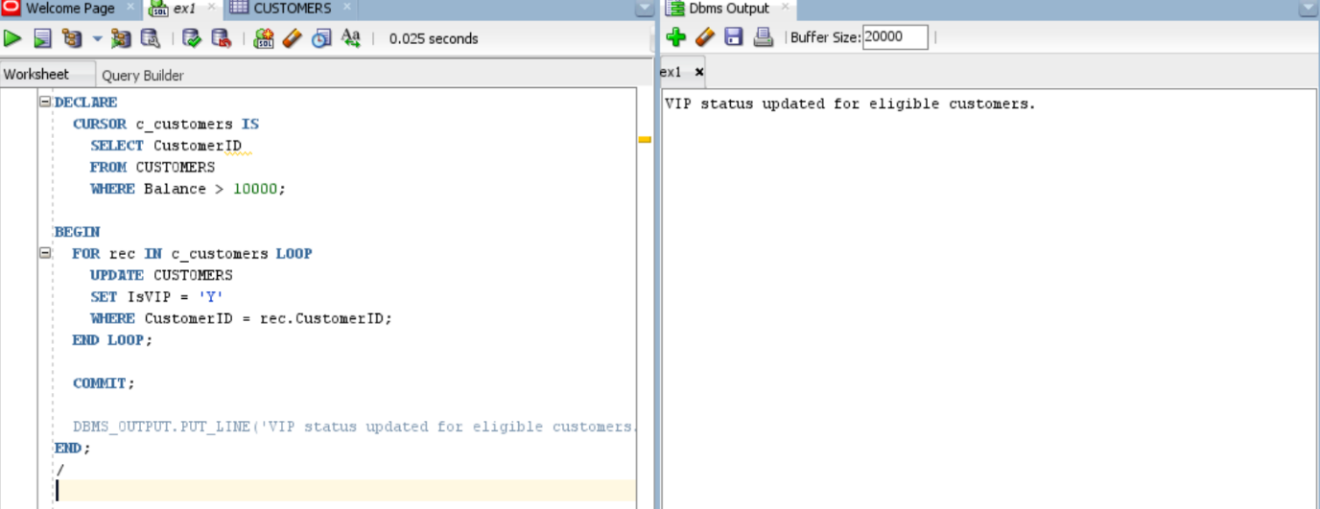

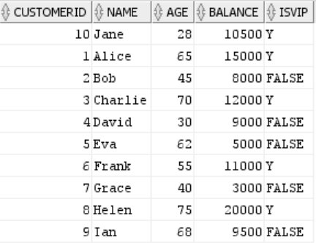

**Scenario 3:** The bank wants to send reminders to customers whose loans are due within the next 30 days.

* + **Question:** Write a PL/SQL block that fetches all loans due in the next 30 days and prints a reminder message for each customer.

**Code:**

DECLARE

CURSOR c_due_loans IS

SELECT l.LoanID, c.Name, l.DueDate

FROM LOANS l

JOIN CUSTOMERS c ON l.CustomerID = c.CustomerID

WHERE l.DueDate BETWEEN SYSDATE AND SYSDATE + 30;

BEGIN

FOR rec IN c_due_loans LOOP

DBMS_OUTPUT.PUT_LINE('Reminder: Loan ID ' || rec.LoanID ||

' for customer ' || rec.Name ||

' is due on ' || TO_CHAR(rec.DueDate, 'DD-MON-YYYY') || '.');

END LOOP;

END;

**Output:**

